# Running head: Installing and Configuring Linux & Firewalls

# CS3910: Assignment 6: Installing and Configuring Linux & Firewalls

# Mordred Cameron

# University of Colorado Colorado Springs

In partial fulfillment of the requirements for CS3910

Instructor: Rhett Saunders

4/13/2024

# Introduction to Installing and Configuring Linux & Firewalls

In this assignment, the outcome provided insight into setting up and installing Linux on Ubuntu and Red Hat operating systems, along with installing firewalls and basic addition of users.

Assignment Results

**Ubuntu Setup:**

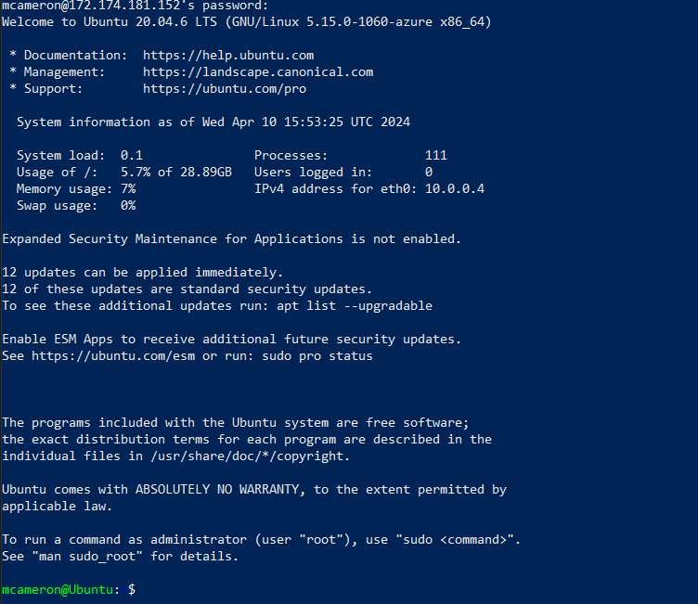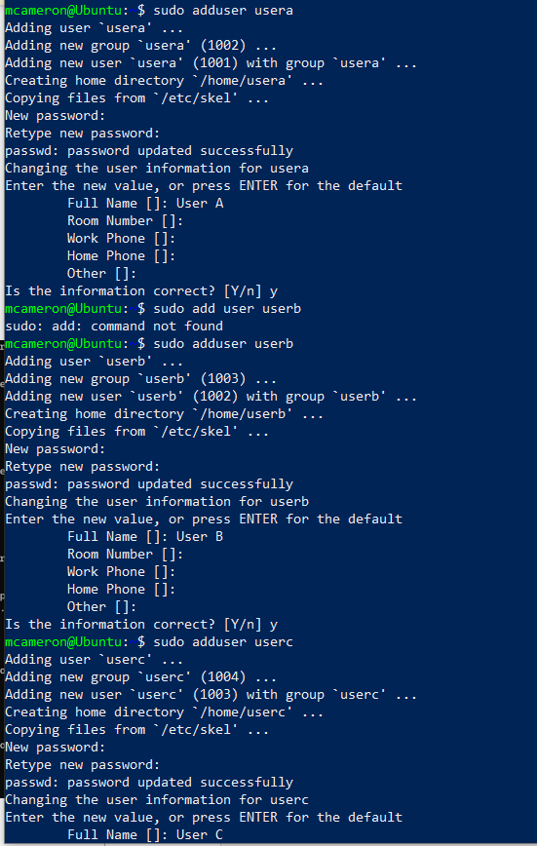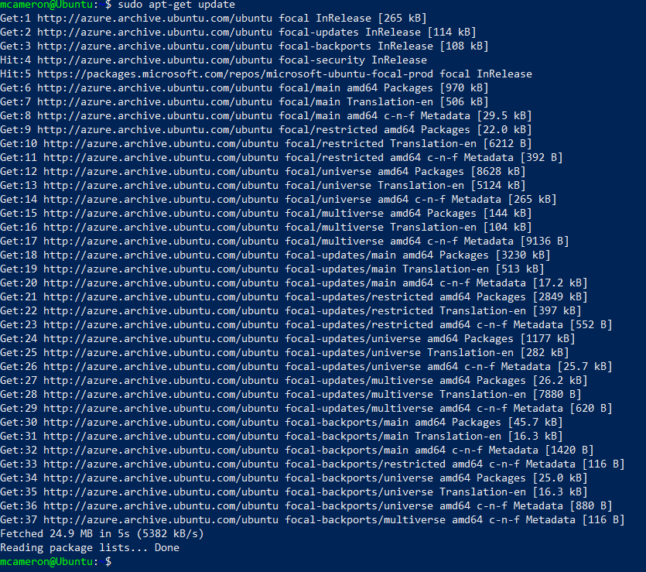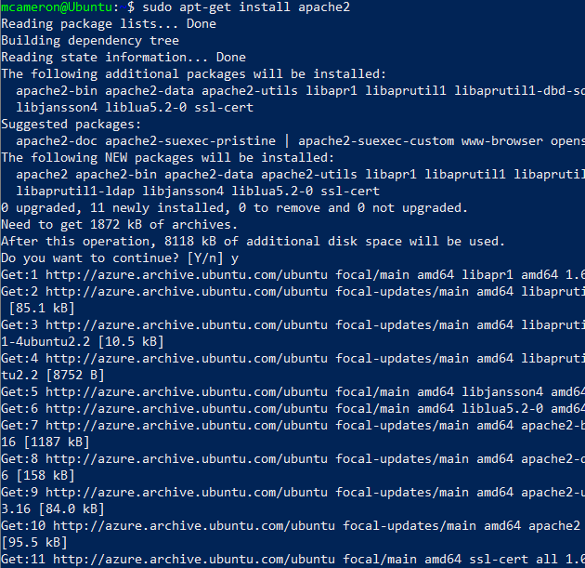

**Red Hat:** (Used centOS due to roccuring subscription error with Red Hat on Azure)

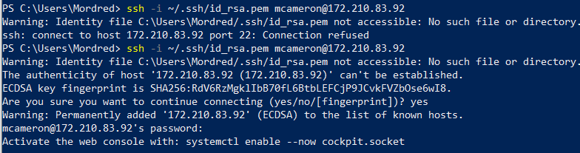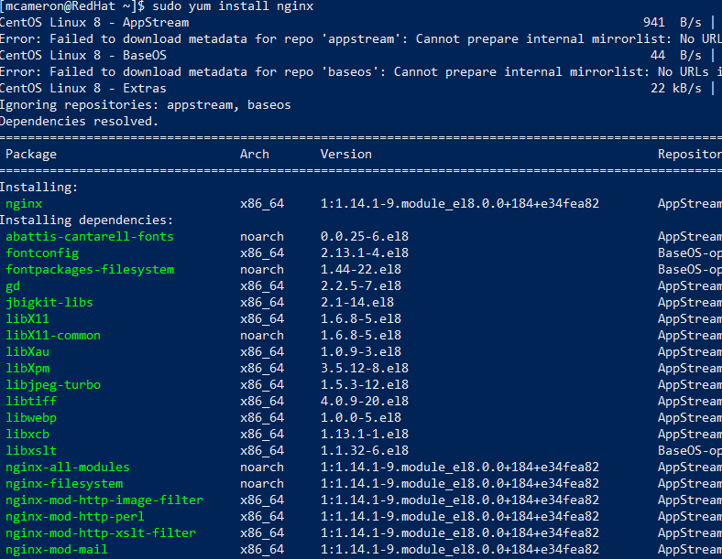

The installation process of both Ubuntu and Red Hat(centOS) were relatively similar. I used Azure for both, and while Ubuntu was easier to set up, I ran into several issues with subcription compatability and verification for RHEL and in the end had to use centOS instead. The syntax for both was quite similar, with small differences like the install commands apt vs yum. Both had simple installs; however, Ubuntu appeared to cater a bit more towards the individual and was a bit more user friendly, while Red Hat was more directed towards the enterprise and was designed as such.

**Compare and contrast:**

Ubuntu:

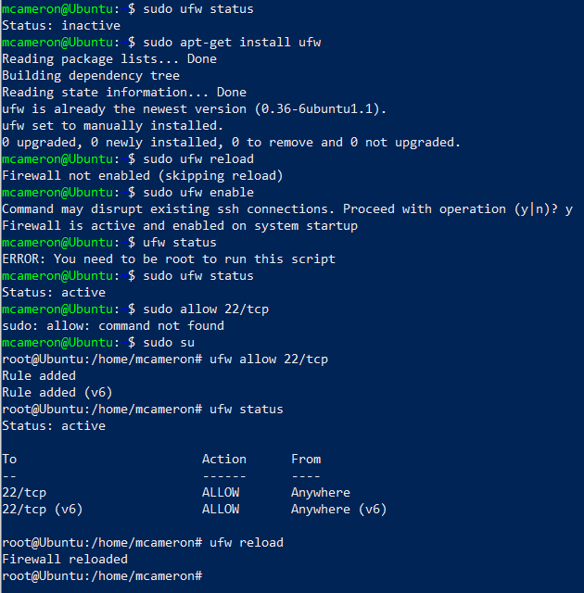

Red Hat:

Ping:

**Results of /etc/group:**

Ubuntu:

Red Hat:

**/etc/sudoers**

**Ifconfig**

Ubuntu:

Red Hat:

**Uname -r**

Ubuntu:

Red Hat:

**Head -10**

Ubuntu:

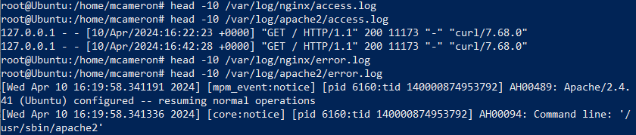

Red Hat:

Conclusion

In summary, I learned how to set up both Ubuntu and Red Hat Linux systems, as well as their respective firewalls. Linux features a more robust security set up out of the box, and benefits from its open source nature (Hasnian & Rafi, 2019). After using both Windows and Linux OS through Azure, Linux seemed to benefit more from its minimal GUI, ran faster on less memory and storage, and was overall faster to set up after the initial learning curve of the command line was overcome. Familiarizing myself with these systems will surely benefit if needed in the future.

References

*Cloud computing services: Microsoft Azure*. Cloud Computing Services | Microsoft Azure. (n.d.). https://azure.microsoft.com/en-us

Hasnain, S. G. M., & Rafi, F. A. (2019). Windows, Linux, Mac Operating System and Decision Making. International Journal of Computer Applications, 975, 8887.